**San Jose State University - Computer Engineering Department**

**Course Name: CMPE187-01/CMPE287-02 – Software Quality Testing**

Homework #2

Semester: Fall, 2023

Instructor: Jerry Gao, Ph.D.

Posted date: 8/30/2023 Due date: 10/21/2023

**Question #1: Basis Path Software Testing (30%)**

Based on the given Java program below, please complete the following questions:

1. Generate a control program flow graph for Sort(…) based on the given Java program.(7%)
2. Compute its Cyclomatic number using cyclomatic complexity. (5%)
3. Generate a graph matrix based on your generated flow graph and compute the Cyclomatic metric. (5%)
4. Identify a basis path set (which consists of a number of basis paths) for Sort(.…) function. (6%)
5. List the basis set of test cases (including test inputs and outputs for each test case) (7%)

Java Program to Implement Selection-Sort(….)

<https://www.geeksforgeeks.org/selection-sort/>

**Question #2: Branch-Based Software Testing (30%)**

Branch-Based Software Testing:

1. Based on your generated program flow graph of Sort(.…) Function, please generate a branch table. (10%)
2. Generate the identified branch test paths. (10%)
3. List the branch test cases based on your identified paths. (10%)

**Question #3 Questions about Software State-based Testing (20%).**

Figure 1 shows a state diagram for an under-test software feature extraction.

Please answer the following questions.

1. Generate a state-based test tree based on given Figure 1. (where “idle” is the initial state) (8%)
2. Identify and list state-based paths for testing in terms of lengths for your test case design. (6%)
3. Please identify and list the state testing paths from “idle” to “handoff”: (6%) (Please avoid the redundant paths)

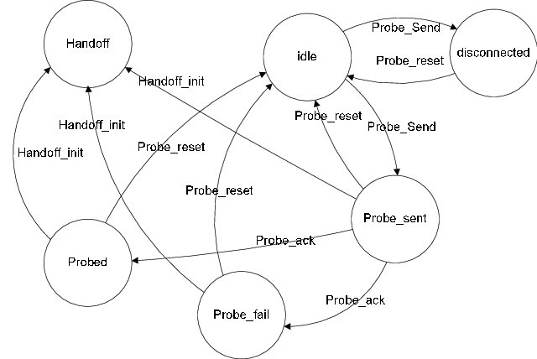

Figure 1 The state diagram

**Question #4: Driverless Car Validation (20%)**

Please search the google map with images to identify and discover your answer to the following questions for AV Testing context modeling.

1. Develop and present a road context model for a selected 4-way intersection with traffic lights and cross-walking with meters. (6%)
2. Develop and present a road context model for diverse road hazards (based on a well-classified classes) (4%)
3. Develop and present a road context model for people crossing street scenarios (based on a well-classified classes). (6%)
4. Develop a road context model for a school bus scenario (based on a well-classified classes). (4%)